**Data Type in SQL**





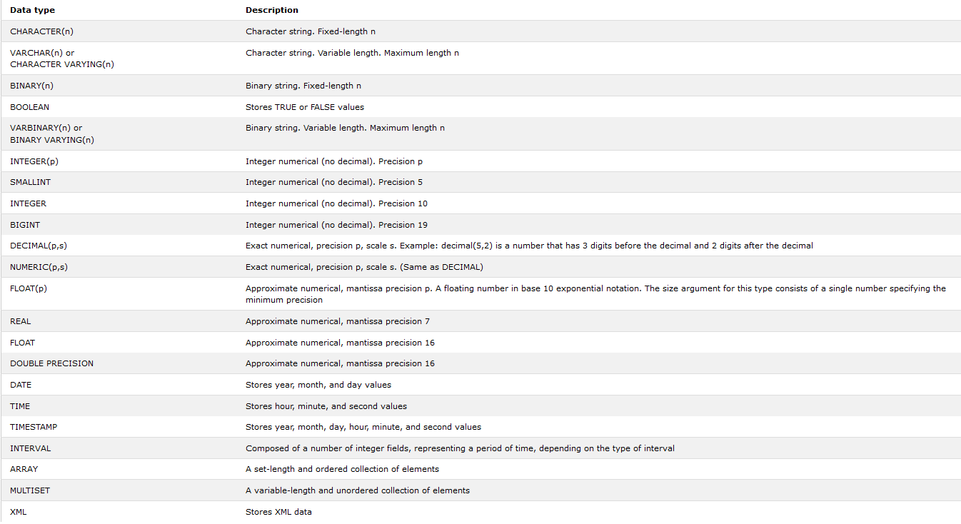

**Q: Why not just use BLOB for all of my text values?**

**A:** It’s waste of space. A VARCHAR or CHAR takes up a specific amount of space, no more than 256 characters. But a BLOB takes up much more storage space. As your database grows, you run the risk of running out of space on your hard drive. You also can’t run certain important string operations on BLOBs that you can on VARCHARs and CHARs.

**Q: Why do in need these numeric types like INT and DEC?**

**A:** It all comes down to database storage and efficiency. Choosing the best matching data type for each column in your table will reduce the size of table and make operation on your data faster.

**Q: Is this it? Are these all the types?**

**A:** No, but these are the most important ones. Data types also differ slightly by RDBMS. So, you’ll need to consult your particular documentation for more information.